App Reskinning: Clickable Prototypes

I redesigned a banking app to make it more user friendly and visually appealing. The application I have chosen has a lot of clutter and text and I tried to eliminate it by creating bigger icons and showing lesser number of options. In my opinion the new design is more accessible, easier to navigate and aesthetically pleasing.

After adding clickable prototypes, my design evolved in various ways. I was able to add multiple states to my screens and connecting them all together made my workflow easier and the app started coming together. I also used UI Kits from the Adobe Marketplace which made the prototype very presentable. I created drop down calendars along with multiple states for the dates in the calendar

The techniques I learnt while doing this assignment have been very useful. Having further practiced prototyping through this assignment, I extended by base knowledge of Adobe XD and the designing process. Creating a flow between my screens made me realize how I would code an application if I were to start from scratch.

**Video Walkthrough:** <https://www.youtube.com/watch?v=xHXRGZRvs6g>

**BEFORE**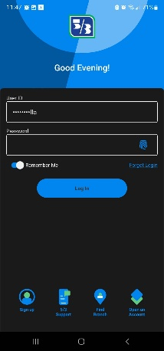 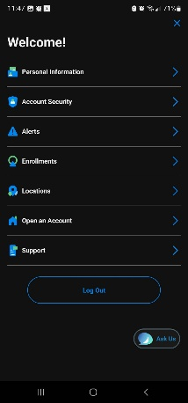 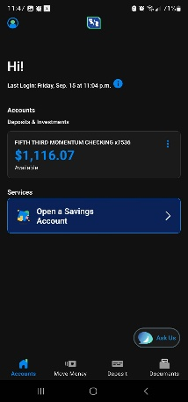 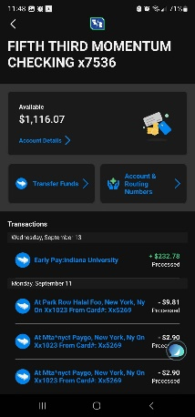 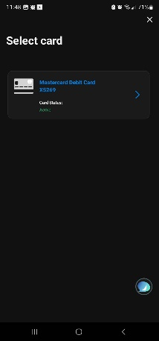 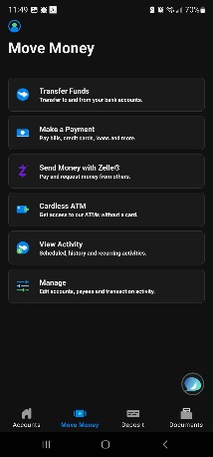

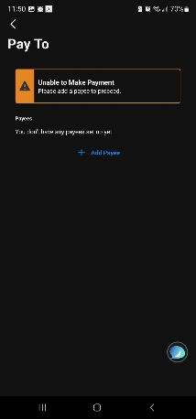 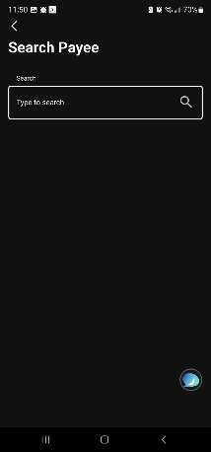

**AFTER** 